Task1:

CODE:

package day7;

import org.openqa.selenium.edge.\*;

import static org.testng.Assert.assertEquals;

import org.openqa.selenium.WebDriver;

import org.testng.Assert;

import org.testng.annotations.Test;

import io.github.bonigarcia.wdm.WebDriverManager;

public class Task1 {

@Test

public void task1() {

WebDriverManager.edgedriver().setup();

EdgeOptions co = new EdgeOptions();

co.addArguments("--remote-allow-origins=\*");

WebDriver driver = new EdgeDriver(co);

driver.get("https://demo.wpeverest.com/user-registration/guest-registration-form/");

driver.manage().window().maximize();

String PageTitle = driver.getTitle();

String ExpectedTitle = "Guest Registration Form – User Registration";

Assert.assertEquals(PageTitle,ExpectedTitle);

}

}

OUTPUT:

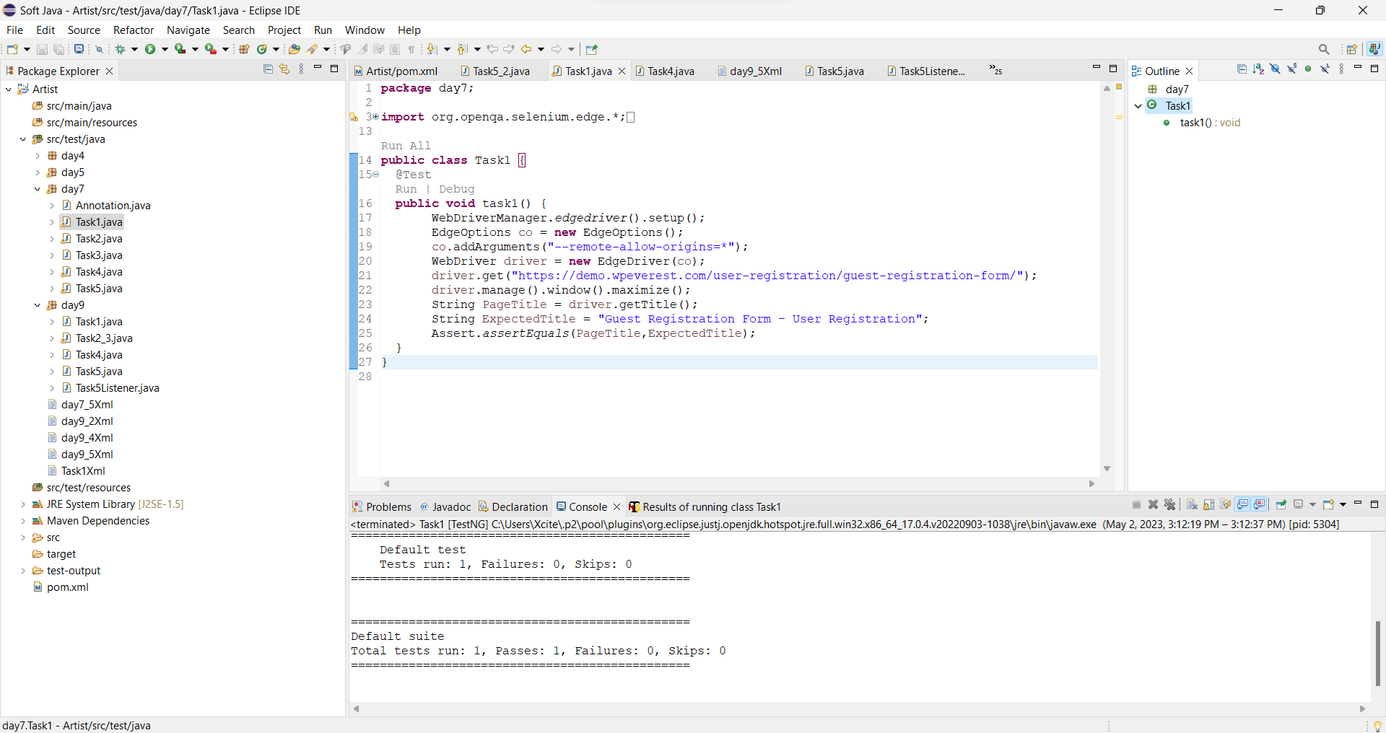

TASK2:

CODE:

package day7;

import java.util.\*;

import org.testng.Assert;

import org.testng.annotations.BeforeMethod;

import org.testng.annotations.BeforeSuite;

import org.testng.annotations.BeforeTest;

import org.testng.annotations.Test;

public class Task2 {

int a,b,c;

@BeforeMethod

public void getData()

{

System.out.println("Enter a,b");

Scanner sc = new Scanner(System.in);

a = sc.nextInt();

b = sc.nextInt();

}

@Test(priority = 1)

public void add() {

c = a+b;

Assert.assertEquals(c,11);

}

@Test(priority = 2)

public void subtract() {

c = a-b;

Assert.assertEquals(c,3);

}

@Test(priority = 3)

public void multiply() {

c = a\*b;

Assert.assertEquals(c,28);

}

@Test(priority = 4)

public void divide() {

c = a/b;

Assert.assertEquals(c,1);

}

}

OUTPUT:

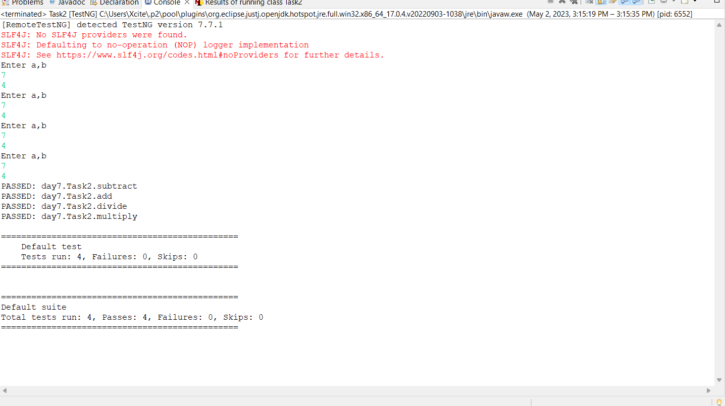

TASK3:

CODE:

package day7;

import org.openqa.selenium.By;

import org.openqa.selenium.WebDriver;

import org.openqa.selenium.edge.\*;

import org.testng.Assert;

import org.testng.annotations.AfterMethod;

import org.testng.annotations.BeforeMethod;

import org.testng.annotations.Test;

import io.github.bonigarcia.wdm.WebDriverManager;

public class Task3 {

WebDriver driver;

@BeforeMethod

public void openPage() {

WebDriverManager.edgedriver().setup();

EdgeOptions co = new EdgeOptions();

co.addArguments("--remote-allow-origins=\*");

driver = new EdgeDriver(co);

driver.get("https://opensource-demo.orangehrmlive.com/web/index.php/auth/login");

driver.manage().window().maximize();

}

@Test

public void pageTest() throws InterruptedException

{

Thread.sleep(3000);

driver.findElement(By.name("username")).sendKeys("Admin");

Thread.sleep(1000);

driver.findElement(By.name("password")).sendKeys("admin123");

Thread.sleep(1000);

String s1 = driver.getCurrentUrl();

driver.findElement(By.xpath("//\*[@id=\"app\"]/div[1]/div/div[1]/div/div[2]/div[2]/form/div[3]/button")).click();

String s2 = driver.getCurrentUrl();

Assert.assertNotEquals(s1,s2);

}

@AfterMethod

public void afterThat() throws InterruptedException

{

Thread.sleep(3000);

driver.close();

}

}

OUTPUT:

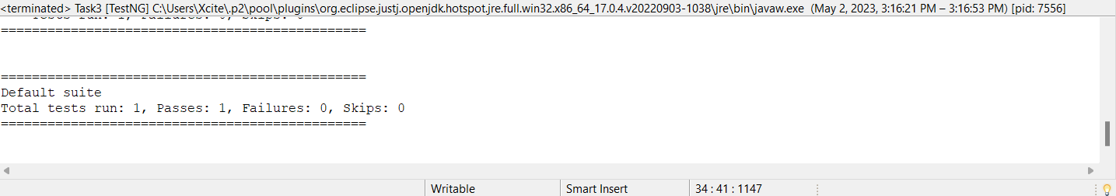

TASK4:

CODE:

package day7;

import org.openqa.selenium.edge.\*;

import org.testng.Assert;

import org.testng.annotations.AfterMethod;

import org.testng.annotations.AfterTest;

import org.testng.annotations.BeforeTest;

import org.testng.annotations.Test;

import org.openqa.selenium.By;

import org.openqa.selenium.WebDriver;

import io.github.bonigarcia.wdm.WebDriverManager;

public class Task4 {

WebDriver driver;

String s1;

String s2;

@BeforeTest

public void open() throws InterruptedException {

WebDriverManager.edgedriver().setup();

EdgeOptions co = new EdgeOptions();

co.addArguments("--remote-allow-origins=\*");

driver = new EdgeDriver(co);

driver.get("https://opensource-demo.orangehrmlive.com/web/index.php/auth/login");

driver.manage().window().maximize();

}

@Test

public void login() throws InterruptedException

{

Thread.sleep(2000);

driver.findElement(By.name("username")).sendKeys("Admin");

driver.findElement(By.name("password")).sendKeys("admin123");

s1 = driver.getCurrentUrl();

Thread.sleep(2000);

driver.findElement(By.xpath("//\*[@id=\"app\"]/div[1]/div/div[1]/div/div[2]/div[2]/form/div[3]/button")).click();

}

@Test(dependsOnMethods = "login")

public void logout() throws InterruptedException

{

Thread.sleep(3000);

driver.findElement(By.xpath("//\*[@id=\"app\"]/div[1]/div[1]/header/div[1]/div[2]/ul/li/span")).click();

Thread.sleep(2000);

driver.findElement(By.xpath("//\*[@id=\"app\"]/div[1]/div[1]/header/div[1]/div[2]/ul/li/ul/li[4]/a")).click();

Thread.sleep(2000);

s2 = driver.getCurrentUrl();

Assert.assertEquals(s1,s2);

}

@AfterTest

public void close() throws InterruptedException

{

Thread.sleep(2000);

driver.close();

}

}

OUTPUT:

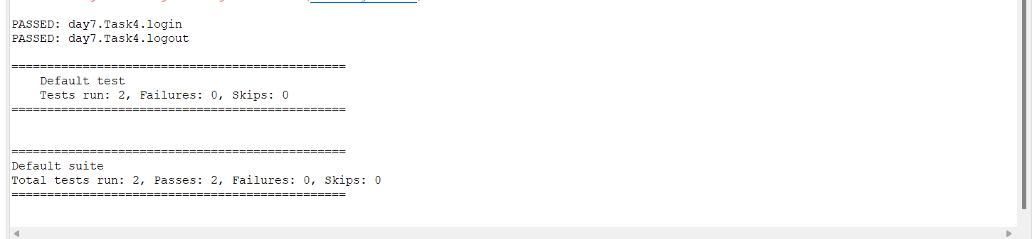

TASK5:

CODE:

package day7;

import org.openqa.selenium.firefox.\*;

import java.util.concurrent.TimeUnit;

import org.apache.hc.core5.util.Timeout;

import org.openqa.selenium.By;

import org.openqa.selenium.WebDriver;

import org.testng.Assert;

import org.testng.annotations.BeforeTest;

import org.testng.annotations.Test;

import io.github.bonigarcia.wdm.WebDriverManager;

public class Task5 {

WebDriver driver;

@Test(groups = {"SmokeTest"})

public void testcase1() throws InterruptedException {

WebDriverManager.firefoxdriver().setup();

FirefoxOptions co = new FirefoxOptions();

driver = new FirefoxDriver(co);

driver.get("https://www.godaddy.com/en-in");

driver.manage().window().maximize();

String s1 = driver.getTitle();

Assert.assertEquals(s1,"Domain Names, Websites, Hosting & Online Marketing Tools - GoDaddy IN");

String url1 = driver.getCurrentUrl();

Assert.assertEquals(url1,"https://www.godaddy.com/en-in");

Thread.sleep(2000);

driver.close();

}

@Test(groups = {"Regression TestCase"})

public void testcase2() throws InterruptedException

{

Thread.sleep(2000);

WebDriverManager.firefoxdriver().setup();

FirefoxOptions co = new FirefoxOptions();

driver = new FirefoxDriver(co);

driver.get("https://www.godaddy.com/en-in");

driver.manage().window().maximize();

Thread.sleep(2000);

driver.manage().timeouts().implicitlyWait(2,TimeUnit.SECONDS);

Thread.sleep(2000);

driver.findElement(By.xpath("//\*[@id=\"id-631b049a-e9c0-4d24-8710-c504745206dd\"]/div[2]/div[1]/ul/li[1]/button")).click();

Thread.sleep(2000);

driver.findElement(By.xpath("//\*[@id=\"id-631b049a-e9c0-4d24-8710-c504745206dd\"]/div[2]/div[1]/ul/li[1]/div/div[2]/div[1]/ul/li[2]/a")).click();

driver.close();

}

@Test(groups = {"Regression TestCase"})

public void testcase3() throws InterruptedException

{

Thread.sleep(2000);

WebDriverManager.firefoxdriver().setup();

FirefoxOptions co = new FirefoxOptions();

driver = new FirefoxDriver(co);

driver.get("https://www.godaddy.com/en-in");

driver.manage().window().maximize();

Thread.sleep(2000);

driver.manage().timeouts().implicitlyWait(2,TimeUnit.SECONDS);

Thread.sleep(2000);

driver.findElement(By.xpath("//\*[@id=\"id-631b049a-e9c0-4d24-8710-c504745206dd\"]/div[2]/div[1]/ul/li[1]/button")).click();

Thread.sleep(2000);

driver.findElement(By.linkText("Domain Name Search")).click();

Thread.sleep(2000);

String s =driver.getTitle();

System.out.println(s);

Assert.assertEquals(s,"GoDaddy Domain Search - Buy and Register Available Domain Names");

}

}

OUTPUT:

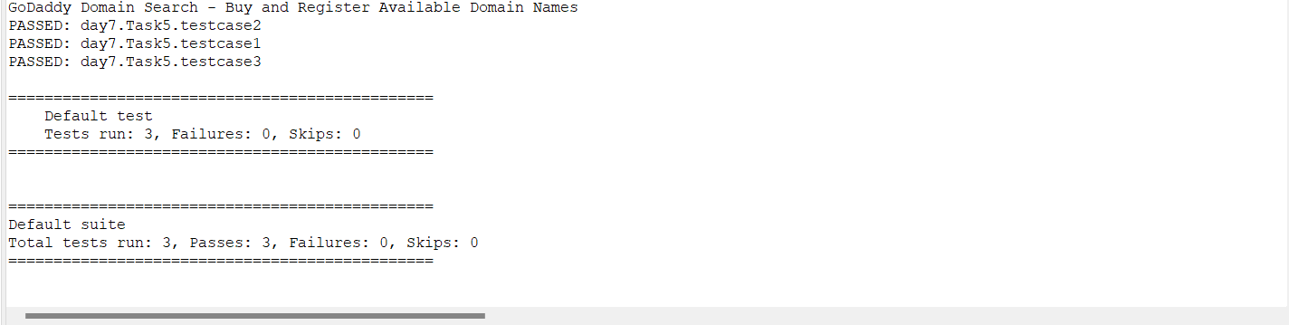

XML:

<?xml version="1.0" encoding="UTF-8"?>

<suite parallel="false" name="Suite">

<groups>

<run>

<include name = "Regression TestCase"></include>

</run>

</groups>

<test name="Test">

<classes>

<class name="day7.Task5"/>

</classes>

</test> <!-- Test -->

</suite> <!-- Suite -->